How to set ModBus

The Device’s ModBus protocol support ModBus RTU Mode, transport can be RS232, RS485 and RJ45 Netport. Please first check your PLC machine whether or not support RTU Mode.
The Device’s ModBus Protocol max support 12bytes card ID, if greater than 12bytes ID, please set reader’s read length less than 12bytes. Using readersoft, ParamSet->ByteLength

Step 1: Open ModBus protocol
Open ReaderSoft file Path,
Double click ReaderSoft.exe
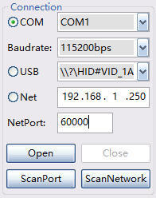, Choose connect port, such as COM, USB or Net(RJ45)
Then click Open button, it will show like this picture
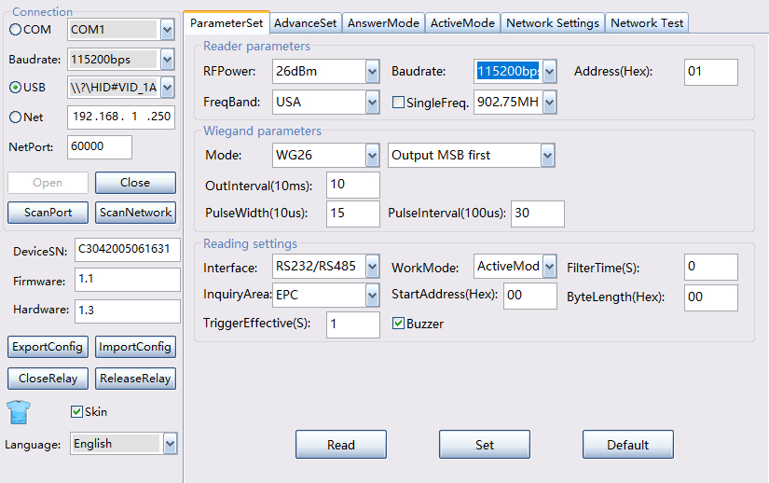
If you want to use RS232 or RS485 to connect to PLC (use RS232/RS485 ModBus),
If use RS232 or RS485 connect to PLC, reader Baudrate is PLC baudrate.

Then set ModBus DeviceID, if use RS232 or RS485, it need set DeviceID, readersoft 485 address is DeviceID, 00 is Modbus broadcast address, can not use it, so it need change to 1 or other value ( < 0x7F)

The set filter time. If not set filter time, PLC will get lot of same tagID.
, Recommend value :3
Then set InquiryArea
The reader default read EPC, it can change to read TID or USER.
StartAddress and ByteLength can not change.
Then set WorkMode is ActiveMode.

After select all parameters, click Set button
Then click AdvancedSet
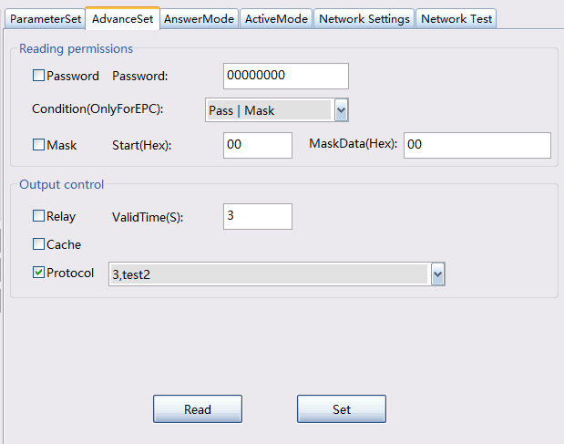
Select Protocol, and select 3.

Then click set button, MODBUS has opened.
If use ModBus TCP, because of ModBus TCP default port is 502, it need change reader Tcp local port to 502.
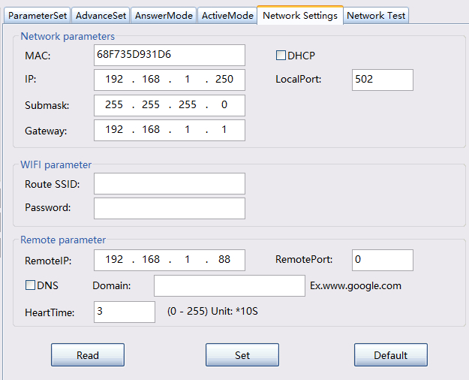
PLC must be the same as the reader’s submask and Gateway.

